**EXPERIMENT NO. 9**

**AIM** Creation of Networks using routers.

**MATERIAL:**

1. Two or more routers (physical or virtual)
2. Computers or devices to connect to the network
3. Ethernet cables (if setting up a physical network)
4. Console cables (if using physical routers)
5. Computer with terminal emulator software (e.g., PuTTY, Tera Term)

**PROCEDURE**:

**Part 1: Initial Network Setup**

1. **Power On the Routers:** If using physical routers, ensure they are powered on. For virtual routers, start the VMs.
2. **Connect to the Routers:** Connect your computer to the router's console port using a console cable for each router if using physical devices. For virtual routers, open your terminal emulator and create connections for each router.
3. **Access the Routers:** Access the command-line interface (CLI) of each router.

**Part 2: Router Configuration**

1. **Basic Router Configuration:**
   * Configure hostnames for the routers to distinguish them.
   * Assign IP addresses to router interfaces and enable those interfaces.
2. **Static Routing:**
   * Configure static routes to enable communication between routers and connected networks.
3. **Dynamic Routing (Optional):**
   * Set up a dynamic routing protocol like RIP, OSPF, or EIGRP to automatically exchange routing information.

**Part 3: Network Device Configuration**

1. **Computer Configuration:**
   * Assign static IP addresses to computers/devices connected to the network.
   * Set the default gateway of the computers to the IP address of the connected router.

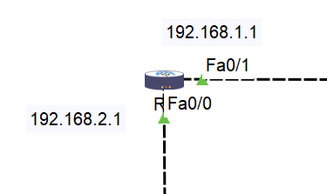

**Part 4: Testing Network Connectivity**

1. **Ping Test:**
   * Use the **ping** command to test connectivity between computers/devices on different networks.
2. **Traceroute Test:**
   * Use the **traceroute** or **tracert** command to trace the path between devices.

**Part 5: Troubleshooting**

1. **Troubleshooting:**
   * Identify and troubleshoot common issues such as incorrect IP configurations, routing problems, or physical connectivity problems.